**Exercise 3: Stored Procedures**

**Scenario 1:**The bank needs to process monthly interest for all savings accounts.

* + **Question:** Write a stored procedure **ProcessMonthlyInterest** that calculates and updates the balance of all savings accounts by applying an interest rate of 1% to the current balance.

**Code:**

CREATE OR REPLACE PROCEDURE ProcessMonthlyInterest IS

BEGIN

FOR account_rec IN (SELECT accountid, balance FROM SavingsAccounts)

LOOP

UPDATE SavingsAccounts

SET balance = balance + (balance * 0.01)

WHERE accountid = account_rec.accountid;

END LOOP;

COMMIT;

END;

/

BEGIN

ProcessMonthlyInterest;

END;

/

SELECT * FROM SavingsAccounts;

**OUTPUT:**

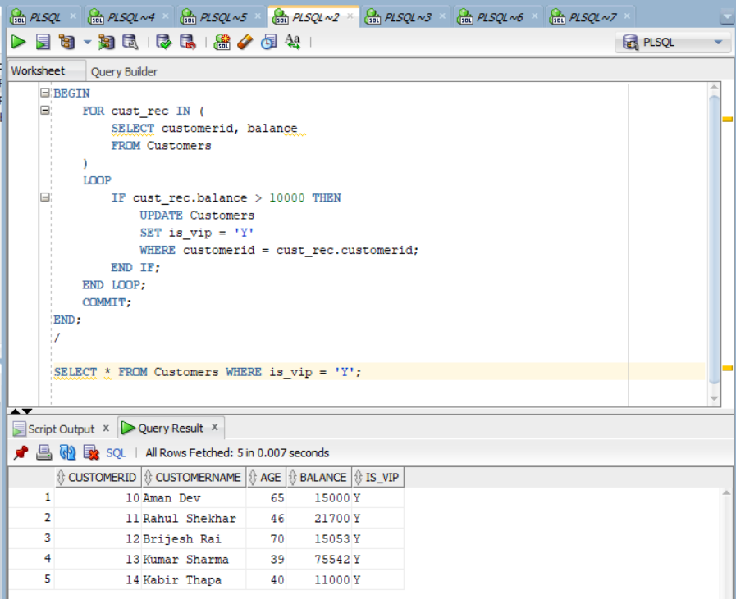

**Scenario 2:**The bank wants to implement a bonus scheme for employees based on their performance.

* + **Question:** Write a stored procedure **UpdateEmployeeBonus** that updates the salary of employees in a given department by adding a bonus percentage passed as a parameter.

**Code:**

CREATE OR REPLACE PROCEDURE UpdateEmployeeBonus(deptid IN NUMBER, bonus_pct IN NUMBER) IS

BEGIN

FOR emp_rec IN (SELECT empid, empname, salary FROM Employees WHERE departmentid = deptid)

LOOP

UPDATE Employees

SET salary = salary + (salary * (bonus_pct / 100))

WHERE empid = emp_rec.empid;

END LOOP;

COMMIT;

END;

/

BEGIN

UpdateEmployeeBonus(101, 12);

END;

/

SELECT * FROM Employees WHERE departmentid = 101;

**OUTPUT:**

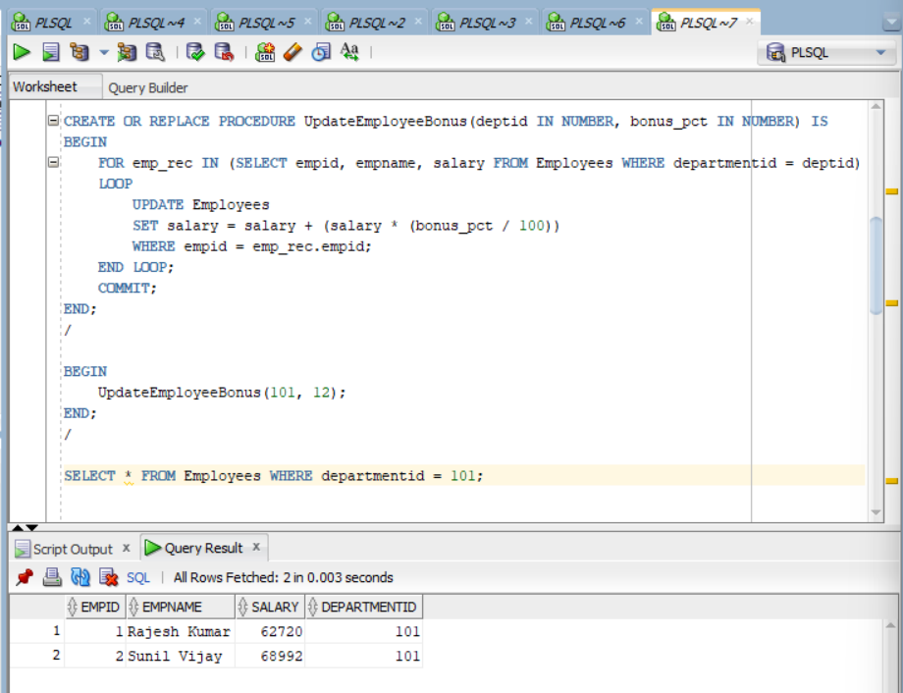

**Scenario 3:**Customers should be able to transfer funds between their accounts.

* + **Question:** Write a stored procedure **TransferFunds** that transfers a specified amount from one account to another, checking that the source account has sufficient balance before making the transfer.

**Code:**

CREATE OR REPLACE PROCEDURE TransferFunds( from_acc IN NUMBER, to_acc IN NUMBER,

amount IN NUMBER) AS balance_from NUMBER;

BEGIN

SELECT Balance INTO balance_from FROM Accounts WHERE accountid = from_acc;

IF balance_from >= amount THEN

UPDATE Accounts

SET Balance = Balance - amount

WHERE accountid = from_acc;

UPDATE Accounts

SET Balance = Balance + amount

WHERE accountid = to_acc;

COMMIT;

DBMS_OUTPUT.PUT_LINE('Transfer done.');

ELSE

DBMS_OUTPUT.PUT_LINE('Not enough balance.');

END IF;

END;

/

BEGIN

TransferFunds(1001, 1002, 500);

END;

/

SELECT * FROM Accounts WHERE accountid IN (1001, 1002);

**OUTPUT:**

